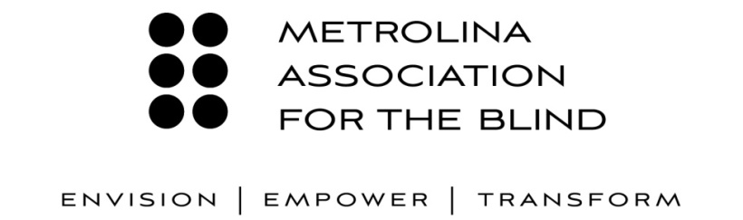

**2015-2016 Annual Report**

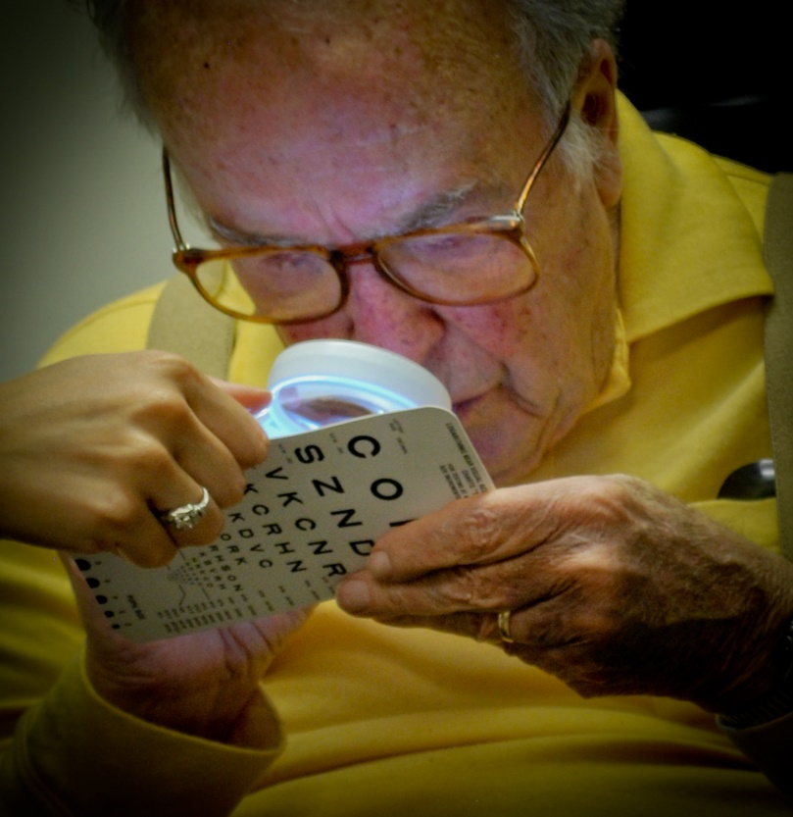

**A Brief History of Metrolina Association For The Blind**

MAB is a 501(c) 3 public non-profit agency established by a group of Charlotte-area residents in 1934 with the assistance of the American Foundation for the Blind and the Charlotte Lions Club. Originally known as the Mecklenburg County Association for the Blind, the name Metrolina Association for the Blind was adopted in 1977 to better reflect the agency’s service area. The mission of MAB is to “reduce or eliminate the daily living challenges imposed upon people by blindness or visual impairment”. By improving the independence, dignity, and confidence of many thousands of visually impaired people over more than eighty years, this commendable service record has earned MAB a solid reputation in the local and national community.

In 2015, our two departments updated their names to better reflect the services provided. Personal Adjustment and Rehabilitation became Vision Rehabilitation Services (VRS); Accessible Braille Services became Accessible Document Services (ADS). In addition, the agency undertook a rebranding process including adopting a new logo and tagline with an updated color-scheme, developing a new website, as well as the creation of a professional marketing video and new department brochures.

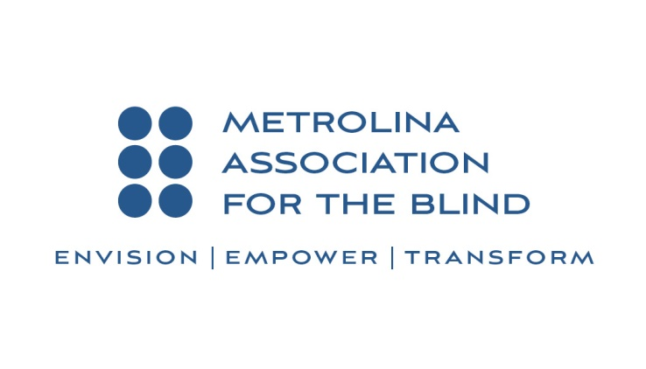

MAB’s Vision Rehabilitation Services (VRS) goal is to provide persons with visual impairment individualized services which empower them to adapt to their vision loss and manage daily living activities independently. The services we provide include therapeutic casework, vision rehabilitation therapy, assistive technology, occupational therapy, orientation and mobility training, low vision medical evaluation and training and support services. Demand for services has doubled in the last ten years and is projected to double again as indicated below by several research studies.

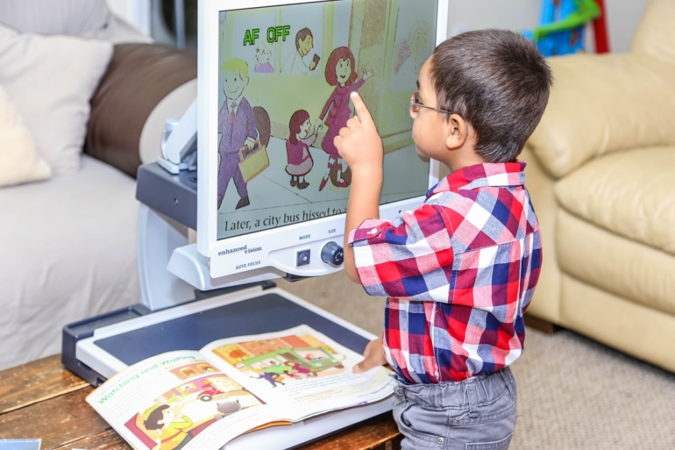

*Image: Young Hispanic boy is standing in front of a closed circuit television pointing to a storybook figure from his book on the CCTV tray.*

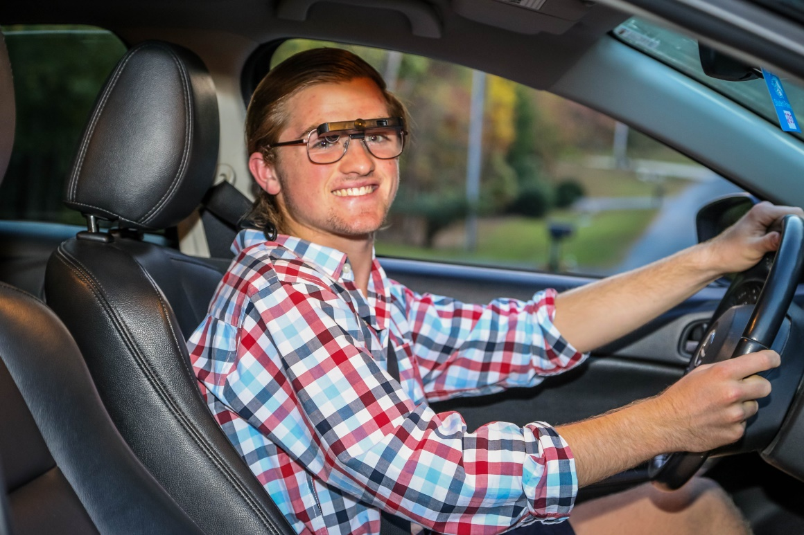

*Image: Teenage boy who has been working with the low vision staff on low vision devices that will make it possible for him to drive a car.*

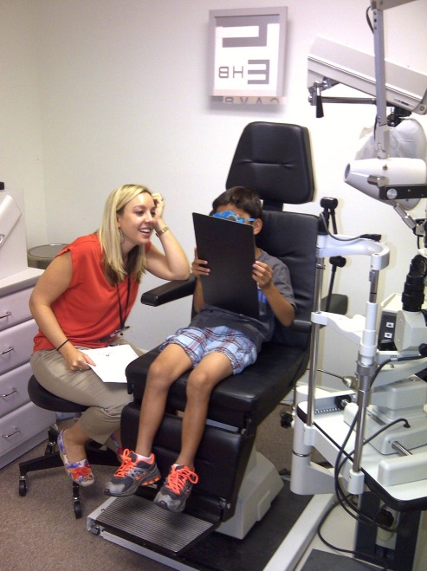

*Image: Dr. Laurie Hoffman, MAB Low Vision Optometrist, providing an exam for a*

*young boy who is reading up close*

The first computerized Braille embosser was acquired in 1985 and opened the door to efficient Braille transcription. MAB, through its Accessible Document Services (ADS) department, became the pioneering leader in providing Braille and large print statements and other documents for financial, utility and telecommunications corporations around the U.S. In 2005, ADS added auditory CD statements and in 2015 Accessible PDFs became a new product. In addition to processing monthly statements, MAB is prepared to transcribe single service documents and Braille textbooks on demand.

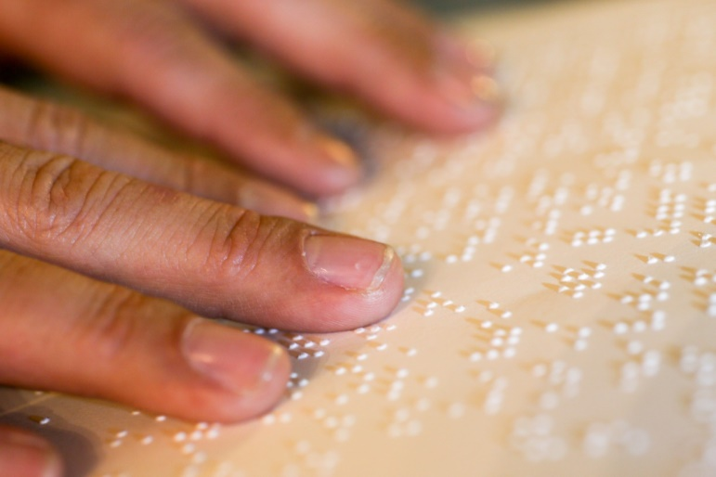

*Image: Two hands are pictured on the left side of the photo reading a page of Braille.*

**Vision Rehabilitation Services**

In 2015/2016, the Vision Rehabilitation Department served 1512 (unduplicated) people with the following services:

|  |  |
| --- | --- |
| Social Services | 1400 |
| Counseling | 42 |
| Orientation and Mobility | 269 |
| Vision Rehabilitation Therapy | 70 |
| Assistive Technology | 100 |
| Group Instruction | 58 |
| Low Vision Therapy | 584 |
| Low Vision Medical | 430 |
| Comprehensive Eye Exams | 79 |
| Transportation | 235 |
| General | 130 |

Adding other services such as patient assistance, aids and appliances, information & referral, public education events and collaborative programming events, VRS provided 4405 overall services in 15/16.

**Accessible Document Services**

The Accessible Document Services (ADS) division of Metrolina Association For The Blind is reaching more people! It is exciting to announce that ADS has provided over 170,000 accessible documents to consumers over the last 12 months. These documents have been sent out on behalf of over 50 companies or lines of business that have utilized our services to meet the needs of their customers. They have enjoyed the quality, security and accountability of the documents we have rendered, and have put their confidence in our products. Many company representatives that visit the Agency see how the monies that are spent by their company to serve their customers are doubly effective by seeing the local clients being served by the MAB social workers, teachers and low vision clinic.

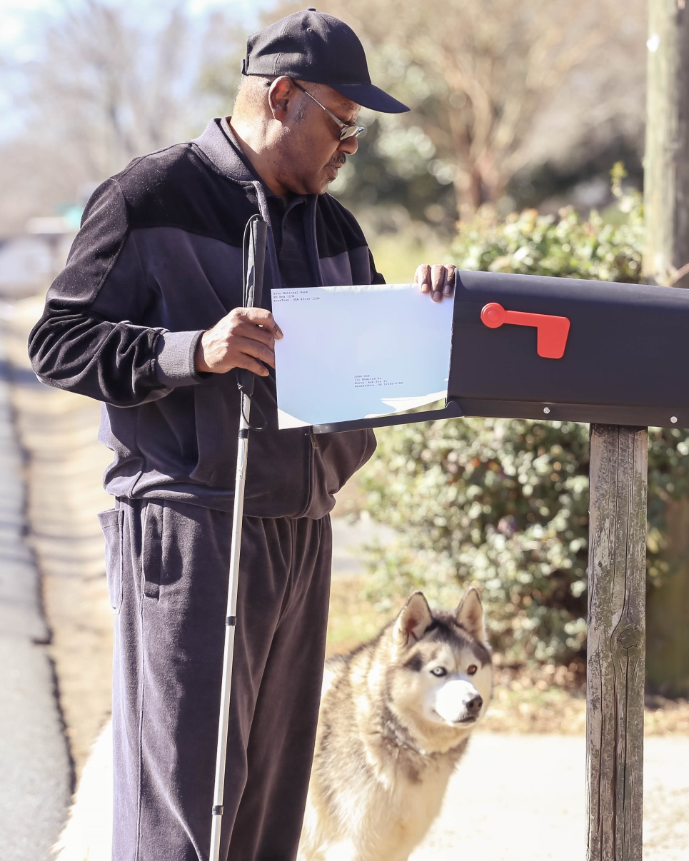

*Image of a visually impaired man getting an ADS envelope out of his mailbox*

With over 30 years of experience in providing accessible statements for the financial, utility, health and telecommunications industries, we are able to provide top quality documents to end users for increased independence and confidence.

Statistics show that the incidence of blindness or severe visual impairment will most definitely increase over the next 20 years, and the ADS department is striving to be prepared to offer the types of accessible documents that will be needed and utilized by these individuals. In all likelihood, you will either be one or know one!

MAB appreciates the businesses that come to the ADS department and strives to earn and keep their confidence and to continue to serve their growing population of visually impaired consumers.

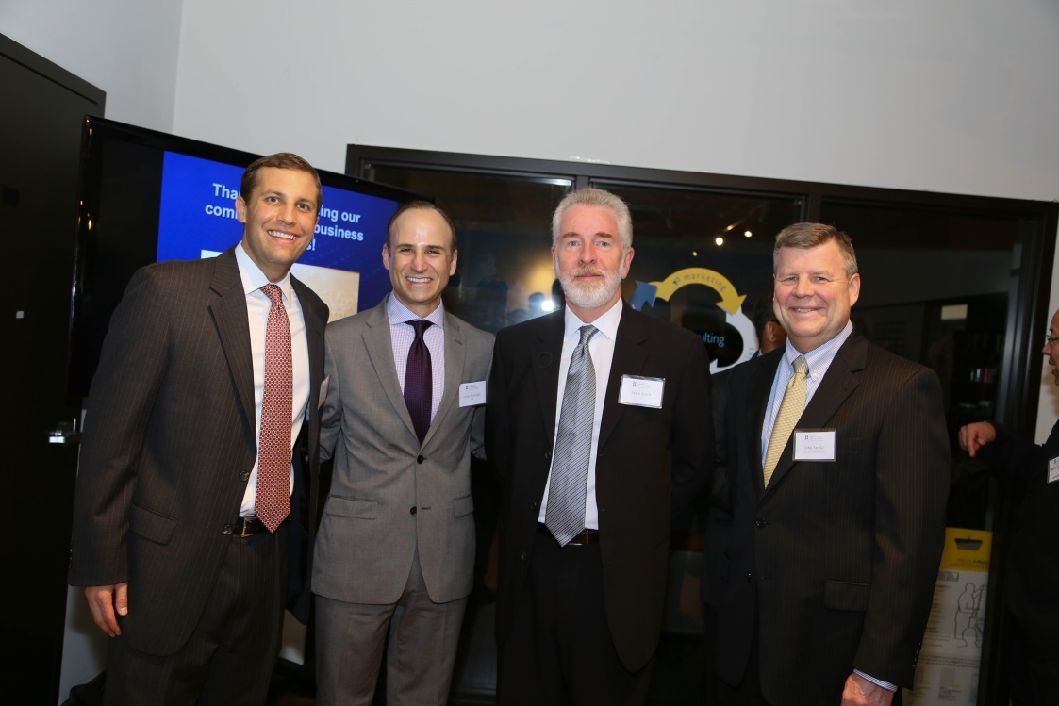

Image of First Annual “Diversity and Inclusion” celebration

Sandy McArthur, Wells Fargo; Greg Montana, FIS Global; Mark Leach, FionnMark Consulting; John Fandel, Bank of America

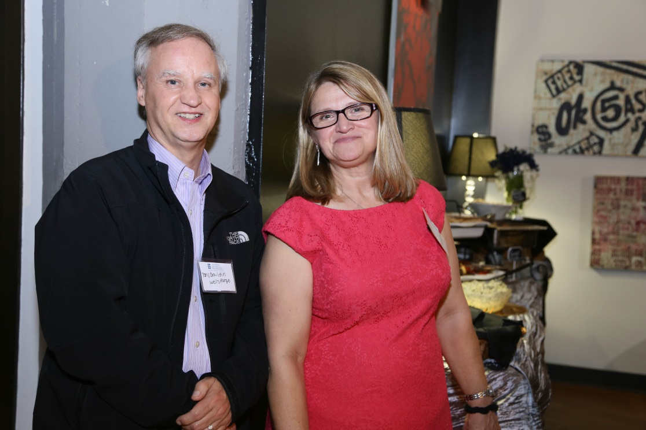

*Image of Tony Bouldin, Wells Fargo and*

*Barbara Bryant, MAB Vice President ADS*

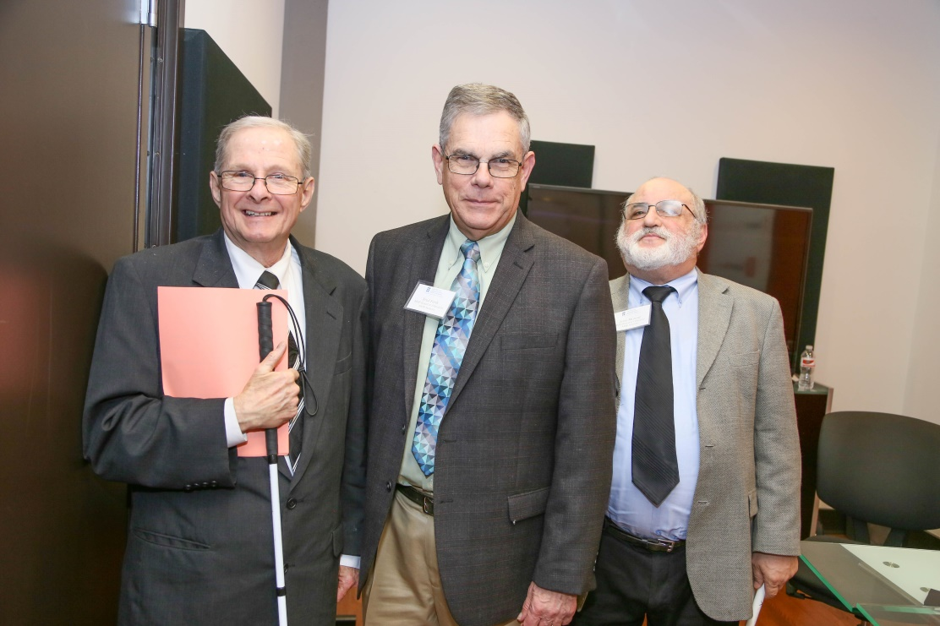

*Image of Steve Caldwell, MAB Seeker; Fred Funk, MAB Board of Directors*

*and Gerry Moreno, MAB Board of Directors Chairman*

**2015 – 2016 Agency Achievements**

The following are a selection of achievements in 15/16 and serve as building blocks for continued agency success in meeting the needs of the blind and visually impaired community.

* The rebranding of MAB included a new website, logo and a professional video by Silent Images. Provident Benevolent Foundation awarded MAB $15K towards the cost of the website.
* ADS produced 170,000 accessible documents for 50 companies or lines of business.
* In fiscal year 15/16, 1512 VRS clients received services totaling 3404 programs. Additionally, support services were provided including 170 Patient Assistance, 36 Public Education, 271 Aids & Appliances, 476 Information & Referrals and 48 Collaborative Programming events.
* The Low Vision Clinic held a mobile low vision clinic once a month in Concord, Monroe or Davidson, NC.
* The Provident Benevolent Foundation awarded for $12,042 for the purchase of low vision equipment.
* New Low Vision Clinic software, Crystal Practice Management, was launched in 2016. It is used for the management of electronic medical records, inventory, billing, scheduling and e-claims.
* MABs first medical assistant and in-house insurance biller were hired to assist the Low Vision Clinic. The additional insurance revenues generated by having an insurance specialist on staff will help sustain the low vision service.
* The new donor database, e-Tapestry by Blackbaud, was launched in 2016. Through this enhanced communication tool, MAB is able to again send email blasts to clients, donors, and corporate customers.
* MAB expanded targeted marketing towards Charlotte corporations and the growing Latino community. MAB received a $15K grant from the Renate, Hans & Maria Hofmann Trust in New York to further our rehabilitation marketing efforts.
* January 2016, MAB was awarded $123,255 through the 5310 FTA Enhanced Mobility of Seniors & Individuals with Disabilities grant for transportation services. In May, we were awarded an additional $13K to be used for our new part-time driver. In 15/16, MAB provided 3224 trips to clients in our service area for medical appointments, shopping, support groups, mini center, equipment delivery and other.
* The Leon Levine Foundation awarded MAB $7500 for general use September 2015.

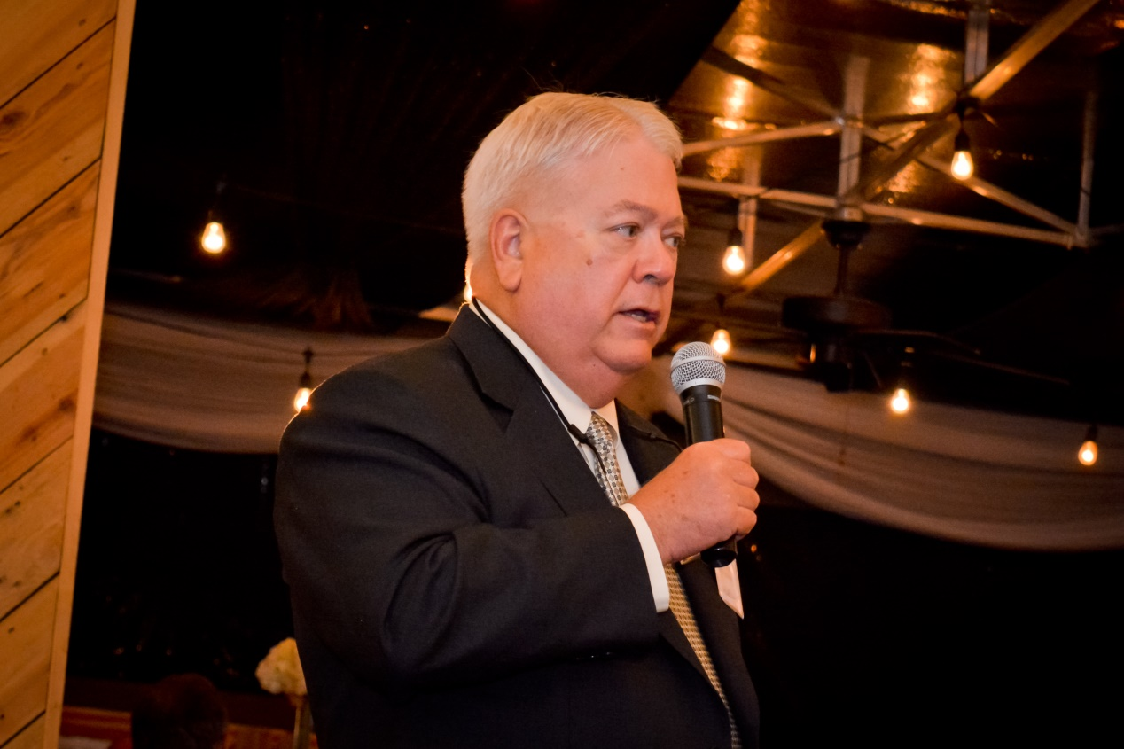

*Image: Bob Scheffel, President and CEO, presiding over the 2015 MAB Gala*

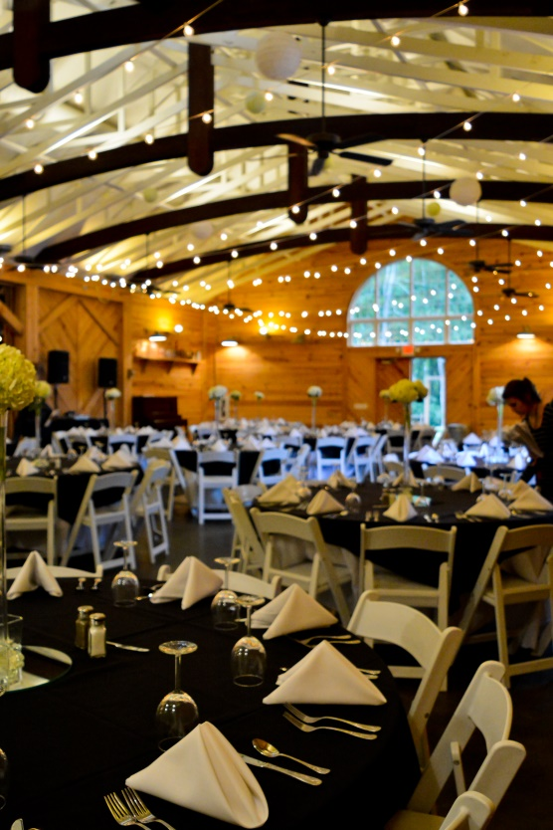

*Image of Alexander Homestead, site of the 2015 MAB Gala*

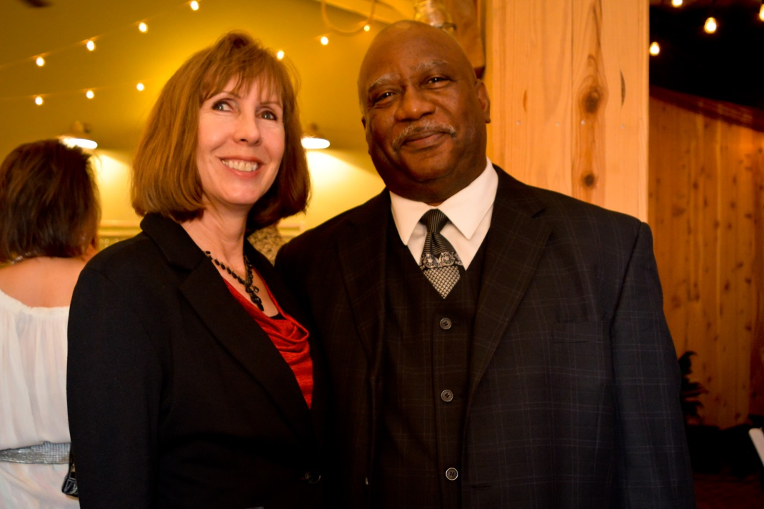

*Image of Dolly Baxter, MAB Case Manager Supervisor,*

*and Will Wortham, MAB Large Printer Editor, Shipper*

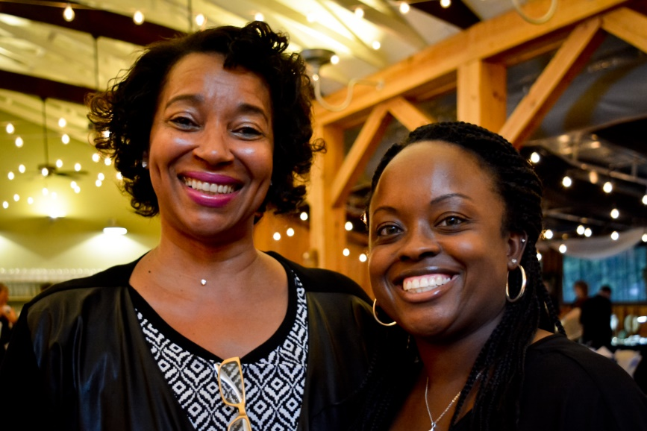

*Image of Rebecca White, MAB Transportation Supervisor,*

*and Shonte’ White, MAB Case Manager*

**A LOOK AHEAD FOR CHARLOTTE**

In 2013, the National Federation of the Blind (NFB) reported that there were 7,327,800 people in the US that report “sight bad enough – even with corrective lenses- that they must use alternative methods to engage in any activity that persons with normal vision would do using their eyes.” In 2013 NFB reported 252,800 people with vision loss in North Carolina. There are somewhat conflicting statistics about the expected growth of vision loss. Some researchers report the doubling by 2030 and more recently a report was released announcing the doubling by 2050. Regardless, the trend is toward increasing numbers of visually impaired people due to the aging baby boomers, the rising incidence of obesity, and the rising prevalence of diabetes.

The Charlotte area population was 1.87M in 2010 according to the Charlotte Business Journal. With Charlotte area growth of 47% by 2030, estimates show the population at 2.74M. Due to this growth, Charlotte may have higher levels of demand for vision services than the average city.

**2015/2016**

**Visionary Society Members ($1,000+)**

Randy and Kathy Allen Jesse Bennett

Charlie Breese Carol Gorelick

Richard R. Jarman Greg and Karen Montana

Helen and Robert Scheffel Sarah and Ken Schwartz

George and Tricia Sistrunk George and Debbie Warren

**20/20 Club Members ($500 +)**

Raymond and Mary Boardman Kevin and Lynne Calos

Robert Carrington Jr. Dufferin Culpepper, II

Erin Darcy Joseph Dyer

Dr. and Mrs. Michael Haake Gail Halverson

Barbara Laughlin Laura and Mark Leach

LeRoy and Brenda Leiker Don and Teresa Meanor

Barry and June Moore Gerald and Madeline Moreno

Julius and Cynthia Schachner Timothy Spaulding

Vann and Julia Taylor Robert and Glenda Tucker

**Optical Circle ($250 +)**

Virginia Anderson Dr. Andrew Antoszyk

Tom and Jeanie Cottingham Frederick and Pamela Funk

Lonnie and Michele Harvey Margaret Hershberger

Robert McAllen Sandy McArthur

Deidre Joyce Milchan-Tobin Susan Reese

Jessie Shefferd John Shelton

Dutta Shetti Ely Tortilleria

Nancy Turbyfill William Turk

**Donors**

Neal and Barbara Aaron Tommy Allman

Jodie Anderson Christine Autry

Betty Arnold Billy Aycock

Mary Dolly Baxter John Beam, Jr

Sue P Beardon Richard Bennett

Evelyn Berger Angela Berry

Ronnie Blanton Lucinda Blue

Wanda Bodford Eleanor P Bonney

Doris Bradley Carol Brooks

Winfred Brown David Browning, MD

William J. Buckler JoAnn Carreras

Joseph Cauley John C. Cerrato

Julia Chambers Louise Chambers

Tim Chambers Julia Clark

Herbert Cohen Arthur Collier

Tom Collins Mabel Conder

Kathryn Constantinides Judith Cook

Harvey Cosper Joe and Carol Costanzo

Ruby Bailey Cox Taylor Croy

Ethel Crutchfield F.M. and Susan Cureton

Clayton S. Curry, Jr. Paul and Kay Davis

Wanda C. Davis Nicholas and Rose Devenuto

Judy G. Dewar Glenn Dixon

W. Weston Dixon Beth and Jeff Ellen

Vermelle Ely Raymond and Shirley Farmer

Merrilee Fellows Virginia R. Fesperman

Brenda Mickles Foote Dr. John W Foust

Alan Freeland Jose' Fumero

Geoffrey Gantt Carolyn Gary

Patty L George Lynda Glugover

Paul and Rebecca Godfrey Kerri Good

Frank Gordon Carolyn Grandy

Alana Green David Green

Orville W Gruebmeyer, Jr. Arthur Harbot

Becky Harris Cynthia Harris

Nancy Harris Shirley Harris

Daryle Hines Lewis and Dorothy Hinson

Thomas Hoban Thomas Hocutt

Laurie Hoffman, OD Mildred Honeycutt

Dr. Judy Hustead Joanne Jacobson

J.P. Jackson Donald and Becky Jenkins

Carolyn Jeter Michael and Christine Jones

Purnima Kapoor A.Bowman Kelly

Roberta Kirk Vicki Koch

Terry Kost Bohdan and Emma Kostyshyn

Eugenia Kramer Joseph Kuntz

Elana Kuvuna Charles Laatz

Sarah Ledbetter Joe and Rita Lee

Bob and Marlene Lewis William and Brenda Lypa

Homayon and Ali Maalizadeh Charles E MacCallum

Dr. Donald MacDonald J Malone

Graham and Susan Mason Agatha R. McCarthy

Karen G. McCorkle Joseph and Paula McGroarty

Gail Mclaughlin Ralph and Brenda Messera

Judy Miller Johnny and Shirley Mills

Jessica Hope and Rosemary Moon Nicole Morris

Laurancene Murphy Kathy Murray

Elizabeth Negus Helen Neil

Linda Sharon Newton Jacqueline O'Donnell

Kevin and Justine O'Donnell Anne Onafowokan

Tina Oshinski Zachary T. Paff

Eric Peterson Lois Phelan

Emma Quinn Kay Rogers

Dr. Michael Rotberg Timothy and Mary Scott

Richard and Janis Silverman Richard and Jayne Simcoe

Jacquelyn Shepard Hattie Shepherd

Michael Shildt Joan Shinn

Patricia Shuping Barbara Skinner

Andrew Skorjanc Leona Smith

Roland M Smith Irene Soler

Helen S Solitario Richard Spangler

Debbie Spillman Robert Stanley

Elizabeth Strack Linda Strobino

Michael Styers Dolores Suddoth

Patricia Swann Dr. Royce Syracuse

Libby Tabor Jerolene Tarry

Deborah Thomas Mark and Sherri Thompson

Dean Tibbitts Rosebud Turner

Rev. and Mrs. Arthur Vincent Marvin Ward

Barbara Wavrick Linda Weir

Paul and Nancy Wohlfeil Fran Woosley

Kenneth B White Debra Whitt

Laura Yaeger Mary Yandle

Betty Young

**In Honor and Memory**

Advance First Baptist Church

In Memory of Johnnie Doub Bailey

Virginia Anderson

In Memory of Virginia Gayle Smith

Christine Autry

In Memory of Thomas Autry

Lucinda Blue

In Memory of Nettie Myrick

Wanda Bodford

In Memory of Johnnie Doub Bailey

Tom Collins

In Memory of Nancy T. Collins

Taylor Croy

In Honor of Nick DeVenuto

F.M. and Susan Cureton

In Memory of Mary Davis

Daughters of Excellence #31

In Honor of Kerri Good

Judy G. Dewar

In Memory of Johnnie Doub Bailey

David Green

In Honor of Bernice Moate

Raymond and Shirley Farmer

In Memory of Johnnie Doub Bailey

Frederick and Pamela Funk

In Memory of Irene Birdsong

Donald and Becky Jenkins

In Honor of Gene and Lib Risher

Michael and Christine Jones

In Memory of Shirley Earie

Eric Peterson

In Honor of Tom Hocutt

Tina Oshinski

In Honor of Dr. Lauire Hoffman

Timothy and Mary Scott

In Memory of Johnnie Doub Bailey

Debbie Spillman

In Memory of Johnnie Doub Bailey

Libby Tabor

In Memory of Johnnie Doub Bailey

Robert and Glenda Tucker

In Honor of Tonya Merecer

**Corporate Sponsors**

9Round Ballantyne Advance First Baptist Church

Alex and Ani Allegro Endowment Fund

AMC Concord Mills 24 Arnold Palmer

Asheville Grayline Trolley Tour Bagel Bin

Balfour Beatty Construction, LLC Bank of America Charitable Foundation

The Benefits Agency, Inc. Ben’s Kosher Deli NYC

Birkdale Golf Club Bluelink Diagnostic Solutions Inc.

Blumenthal Performing Arts Center Buffalo Bills

Carolina Panthers CEENTA

Charlotte Ballet Charlotte Hornets

Charlotte Knights Charlotte Metro Credit Union

Charlotte Symphony Orchestra Cheesecake Factory

Chicago Cubs Chipley Bible Class

Cloverleaf Handcrafted Jewelry The Comedy Zone

CPCC Theatre CPI Security

Crayola Experience Orlando Dallas Cowboys

Daughters of Excellence #31 Delta Gamma Sorority

Denver Broncos Disney

Discovery Times Square Duke Energy Foundation Matching Gifts

Envision Extreme Pool Plastering LLC

Fig Tree Restaurant FIS Global

Fresh Market Federal Transit Administration 5310

Foundation for the Carolinas Gourmet Gift Baskets

Great Harvest Bread Co. Great Wolf Lodge

Harris Teeter Healthy Home Market

Home Goods Massachusetts Horizon Eye Care

Indian Trail Lions Club Jason’s Deli Epicenter

Kendra Scott Design SouthPark Lenny Boy Brewery

The Leon Levine Foundation Lorenzo’s Pizzeria

Marshall’s Home Goods MA` Maryland School for the Blind/Mike Bina

Metrolina Printing & Promotional, Inc. MLB

Monterrey Mexican Rest. Of Monroe Nascar Hall of Fame

National Federation of the Blind New York Skyride

Newton Vision Center Norsan Media

North Carolina Symphony Oakley

Omni Grove Park Inn Asheville Packard Place

PF Chang Perry’s Fine, Antique and Estate Jewelry

The Pfizer Foundation Provident Benevolent Foundation

Publix Rack Room Shoes

Raffaldini Vineyards Red Box

Renate, Hans & Maria Hofmann Trust Sephora, Inc.

Skybrook Golf Club Sonny’s BBQ

Southeastern Institute Starbucks

STOMP off broadway TJ Maxx Massachusetts

Top of the Rock, NYC Toscana

Total Wine Trader Joes Metro

Trader Joes University US National Whitewater Center

Wal-Mart Waterford Gold Club, Fort Mill

Wells Fargo Wendy’s

Whole Foods Huntersville Wild Wings Cafe

Williams Transco

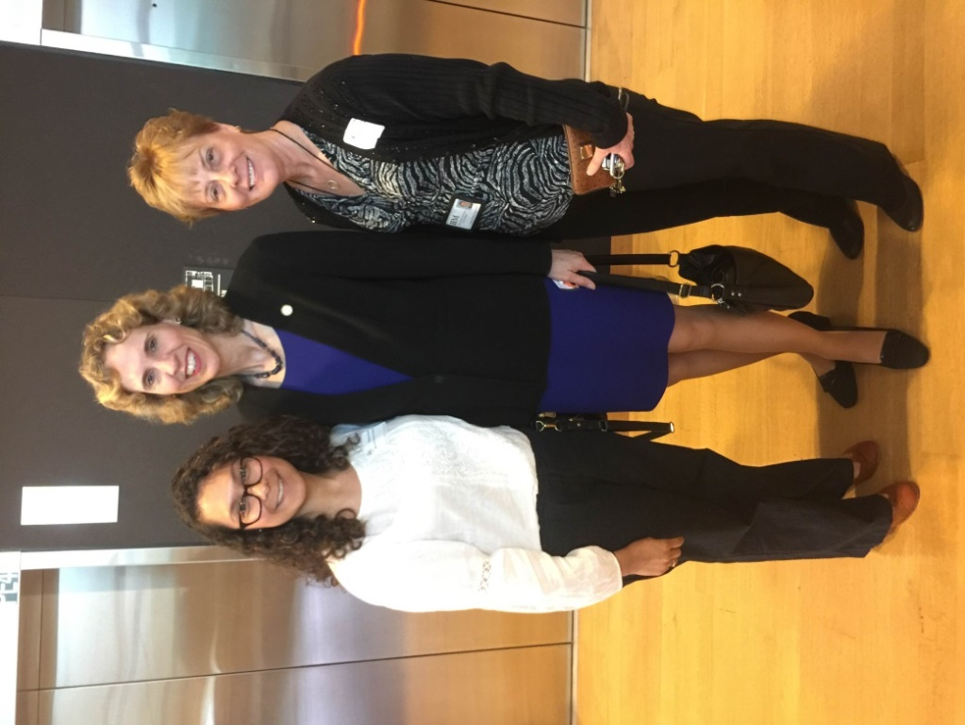

*Image of Paloma Pozos, MAB Hispanic Community Coordinator, Mayor Jennifer Roberts, and Laura Park-Leach, MAB Senior Vice President, attending the*

*Latin American Chamber of Commerce luncheon*

**2015/2016 MAB BOARD OF DIRECTORS**

Gerry Moreno, Chairman

Kevin Calos JoAnn Carreras

Tim Chambers Dufferin C. Culpepper II  
Erin Darcy Glenn Dixon

Fred Funk Lonnie Harvey, Jr.

Spencer Lomax Sandy McArthur

Greg Montana Lynne Nash

Jim Roberts Andy Skorjanc

Tim Spaulding George Warren

**VOLUNTEERS**

William DeGrauw Delta Gamma Sorority

Beth Ellen Susan Reese

MAB Seekers: Steve Caldwell

JoAnn Carreras

Rose DeVenuto

Fred Funk

Antonio Garcia

Tom Lacy

Gerry Moreno

Linda Sharon Newton

Himani Shetti Pranita Shetti

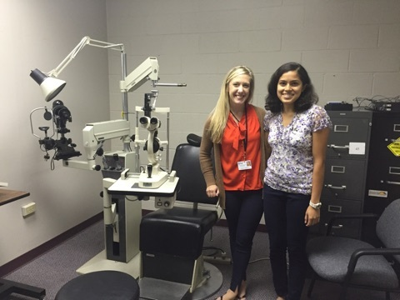

*Image of Dr. Flaherty, MAB LV Optometrist, and Himani Shetti, MAB volunteer*

**MAB STAFF**

Robert R. Scheffel, President and CEO

Hasnaa Abouzaid Dolly Baxter

Holly Bullock Barbara Bryant

John Cerrato Hayden Clontz

Hope Clontz Ali Costanzo

Heather Couch Melissa Crist

Andrea Devoe Maggie Edmunds

Earthlun Ferguson Dr. Brittany Flaherty

Kerri Good Rich Hartness

Dr. Laurie Hoffman Amy Ingebretson

Mary Klattenhoff Roxana Lopez

Sarah Milledge Paola Montoya

Laura Park-Leach Kim Petty

Phil Powell Paloma Pozos

Angie Ryan Jason Sattler

Crystal Sharr Chaunte Skalbe

Ian Smith Tess Thompson

Josh Truong Caroline Utz

Joanna Welch Rebecca White

Shonte’ White Chris Wilkins

Will Wortham

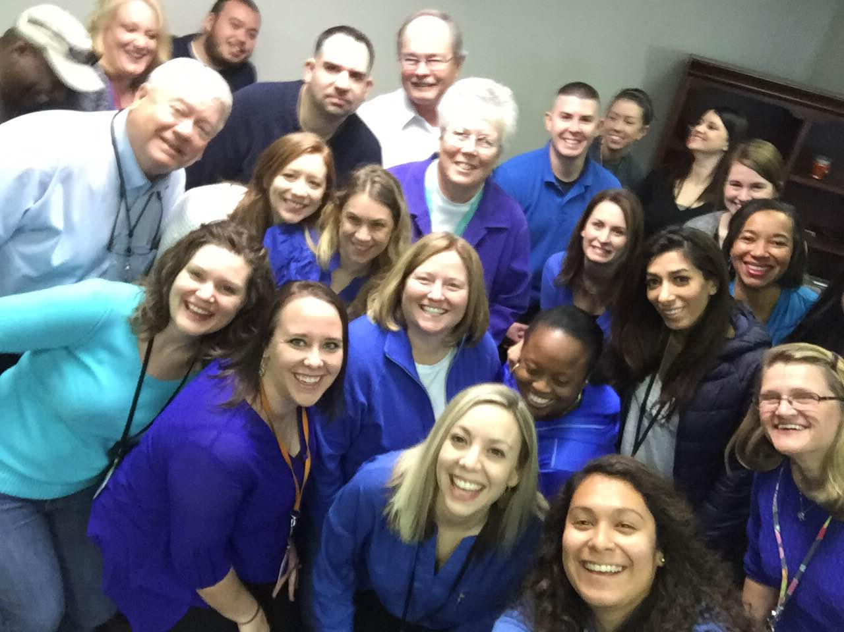

*Selfie image of MAB staff*

**